

**User Experience Engineering**

**2021**

Lab Practical 03

Identify user groups**Bank Of Ceylon Mobile Banking Application**

Sri Lanka Institute of Information

Group ID: **2021S2_REG_WE_47**

Submitted by:

1). IT18212914 - M.J.K. Wickramasinghe

2). IT19025018 - Ravindu Tharaka H.W

3). IT19174990 - Pathirana G.A.P.I.U

4). IT19994338 - Mihisuru E.A.S

**Bank Of Ceylon Mobile Banking Application**

* **Identifying user groups**

Since we have chosen BOC mobile banking app our targeted user groups will be the ones who has fulfilled all of the below criteria.

* Having a savings account at Bank of Ceylon.
* Having a debit card which is currently active.

When we are examining further, we had to classify the above user group into subgroups where no user will be missed during the analysis. As without any difference in tech savviness, careers and any other basic characteristics or needs we are having a huge user base. So that we all agreed to categorize them on age range which will have the most possible and fair distribution covering all users. They are 18 – 25 years, 25 – 40 years, 40 – 60 years and above 60 years.

* **Work distribution among members**
* **Persona creation and empathy map**

As we decided to cover all the user groups identified each of us selected one group and did a little research on the user group, we are responsible for. With the information we collected we decided to do create the persona of the responsible user group and the empathy map also created depending on the respective user group.

Selected user group and the responsible members are as below:

|  |  |
| --- | --- |
| Age Range | Member |
| 18 – 25 years | M.J.K. Wickramasinghe |
| 25 – 40 years | Pathirana G.A.P.I.U |
| 40 – 60 years | Ravindu Tharaka H.W |
| Above 60 years | Mihisuru E.A.S |

* **User Stories and User flows**

We created them mostly based on our function which we took the responsibility of the designing.

* **Service blueprint**

In the beginning we all got together via teams and after deciding the user groups we discussed on the service blueprint. We all went through the documentations on the service blueprints and depending on the example given we identified the necessary border lines, interfaces, services and third-party processes and interaction. Leader took notes on them and designed the final service blueprint.

**Bank Of Ceylon Mobile Banking Application**

1. ***Create Personas***
2. **Text

   Description automatically generated with low confidenceIT18212914 - M.J.K. Wickramasinghe**
3. **Graphical user interface

   Description automatically generatedIT19025018 - Ravindu Tharaka H.W**
4. **Graphical user interface, text, application

   Description automatically generatedIT19174990 - Pathirana G.A.P.I.U**
5. Graphical user interface, application, Word

   Description automatically generatedI**T19994338 - Mihisuru E.A.S**
6. ***Empathy maps***
7. **IT18212914 - M.J.K. Wickramasinghe.**

**FEELS**

**THINKS**

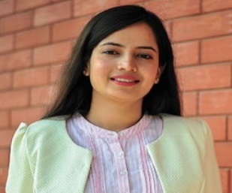

**SAYS**

**DOES**

**I was seeking for mobile banking.**

**Does it send e-receipts for every transaction?**

**Is the app reliable.**

**What bank has the friendliest mobile banking app?**

**I need it to support android and iOS both.**

**I want to do own account transactions.**

**Does it run smooth and fast?**

**I want to do overseas banking.**

**I use BOC accounts.**

**Would have been more reliable.**

**Easy credit card payment is a must.**

**Easy understanding of functions.**

**Why not simple?**

**Wasting too much time?**

**I want to do international transactions.**

**I want something fast.**

**Why are they requiring lots of unnecessary details?**

**Great if it has own account transactions.**

**Excited**

**Selective**

**Consider availability**

**Positive**

**Does things simply.**

**Handles many credits cards & current accounts.**

**All the fund transactions are done online.**

**Takes risks.**

**Strong**

**Goal oriented**

**eidetic**

**impatient**

**Enthusiastic**

**Makes big decisions.**

**Consider the value of time.**

**Lists pros and cons.**

**Gives much priority to customers /suppliers’ trust and bond.**

**Handle lots of major & important transactions.**

**SHAKUNYA**

1. **IT19025018 - Ravindu Tharaka H.W**

1. **IT19174990 - Pathirana G.A.P.I.U**

1. Diagram

   Description automatically generated**IT19994338 - Mihisuru E.A.S**
2. ***User stories***
3. **IT18212914 - M.J.K. Wickramasinghe**

As a parent of an undergraduate student at SLIIT,

I want to transfer registration fee of RS.175 000 for the new semester from my BOC account in Kandy branch to SLIIT BOC account at Kollupitiya branch via mobile banking app.

So that I can safely transfer money in this covid situation, and my child can continue the degree program without facing any interruption.

As an entrepreneur,

I want to transfer funds to my current accounts in the same bank

So that I can issue my suppliers checks when needed.

1. **IT19025018 - Ravindu Tharaka H.W**

As a businessman

I want to handle bill payments.

so that I can make the business more efficient.

As a businessman

I want to view messages and contact details.

So that I can maintain a good relationship with the bank.

1. **IT19174990 - Pathirana G.A.P.I.U**

As a user/account holder

I want to calculate my monthly budget

so that I can track my savings and expenses easily.

As an account holder

I want to transfer money from my account to another account in a different bank.

so that I can do my business transactions without hustle.

1. **IT19994338 - Mihisuru E.A.S**

As a policeman

I want to transfer money online.

so that I can save my time.

As a policeman

I want to pay for credit card.

so that I can easily settle it.

1. ***Identify user flows***
2. 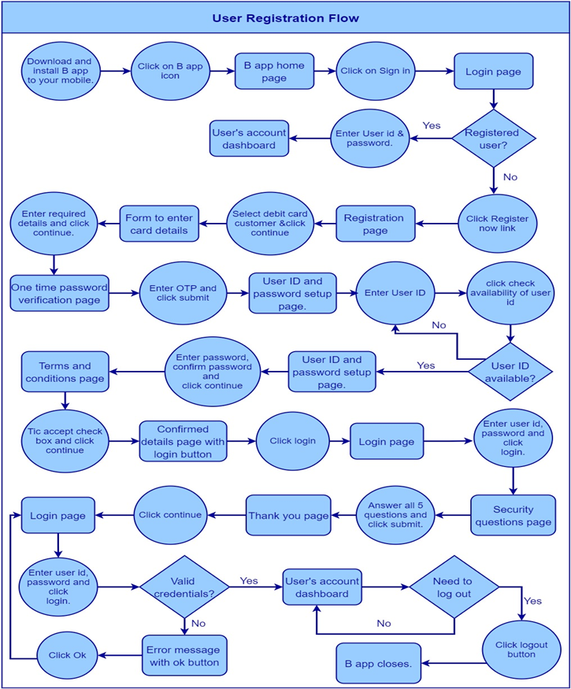**IT18212914 - M.J.K. Wickramasinghe**

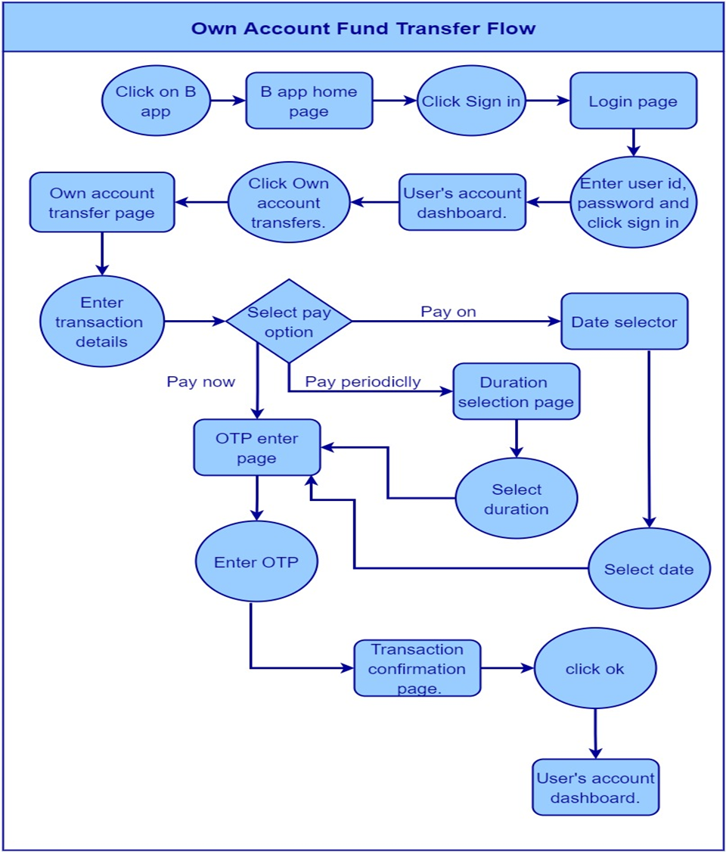

1. **IT19025018 - Ravindu Tharaka H.W**

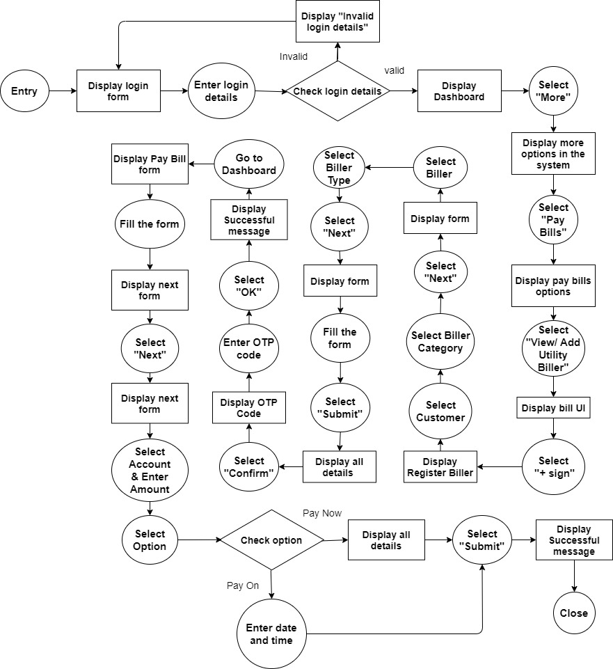

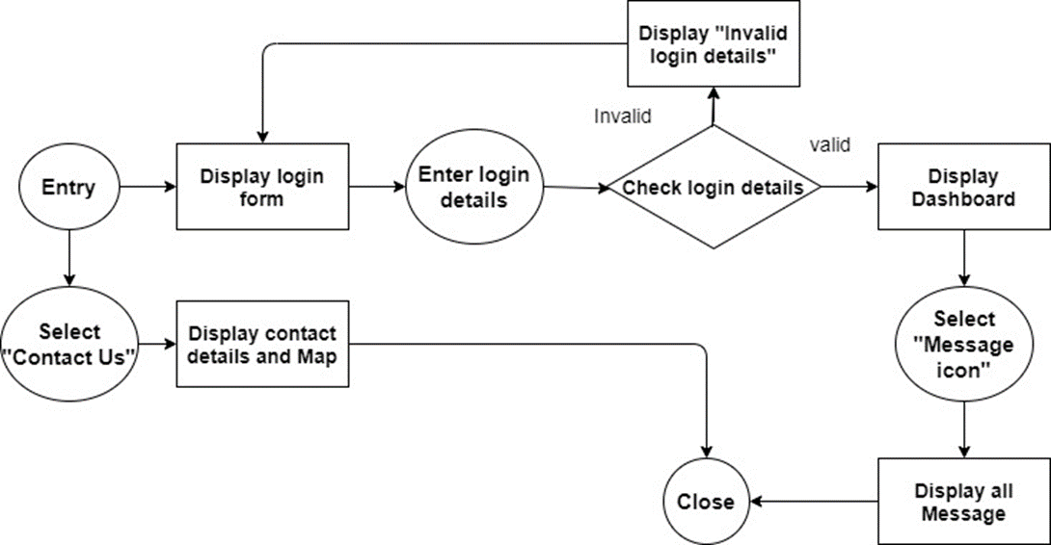

1. **Diagram

   Description automatically generatedIT19174990 - Pathirana G.A.P.I.U**
2. **IT19994338 - Mihisuru E.A.S**

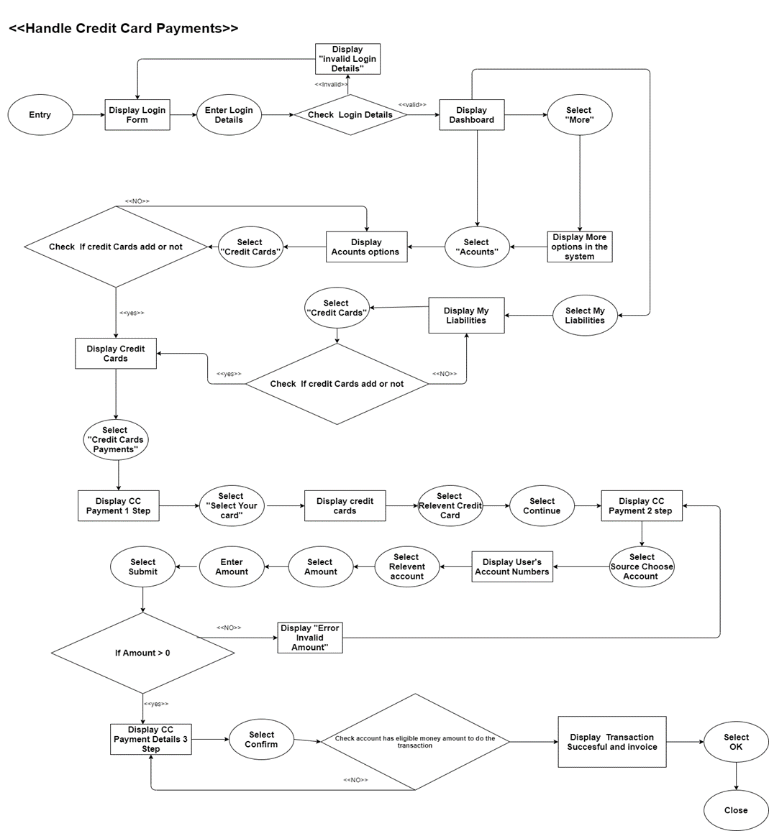

1. ***Service Blueprint***

